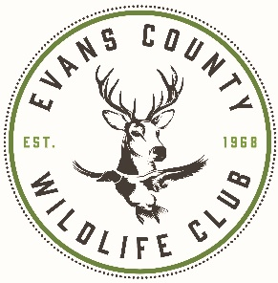54th Annual

Claxton Rattlesnake & Wildlife Festival

March 13 & 14, 2021

Food Vendor Application

**ECWC**

**PO Box 292, Claxton, GA 30417**

**Phone: 912.739.3820 Fax: 912.739.3827**

[**rattlesnakewildlifefestival*@yahoo.com***](mailto:rattlesnakewildlifefestival@yahoo.com)

***Deadline: January 1, 2021***

*There will be a $20 late fee*

Quantity Amount Due

__________ 16’wide and 20’ deep Outside Space @ $550 __________

__________ Basic Electricity – 110 Volt on 30 Amp Max Breakers – $25.00

2 Plugs per Booth Space (You must provide extension cord)

Enclose a Check or Money Order payable to ECWC for this amount: Total ___________

**Camper/RV spaces are limited and will be on a first come basis with NO charge**

**NO electrical hookups or dumping stations are available.**

Name:

Company Name:

Mailing Address:

City: State: Zip:

Home Phone: Work Phone:

Website: Email Address:

Space location request: (The Festival Committee will attempt to honor special requests but event officials cannot give preferential treatment.

It is not guaranteed that you will receive this space.)

This information is for Evans County Wildlife Club’s use only.

Date App Rec’d _________________________ Initials _____________ Approved or Denied

Date Notified ___________________ Notified by phone or e-mail Approval Number _______________________ Exhibit Location _________

Amount Rec’d __________________________ Check or Money Order # __________________________________

Return to:

MENU ITEMS

Please list the items on your menu and note the price range of each items.

1. ____________________________________________________$___________________
2. ____________________________________________________$___________________
3. ____________________________________________________$___________________
4. ____________________________________________________$___________________
5. ____________________________________________________$___________________
6. ____________________________________________________$___________________
7. ____________________________________________________$___________________
8. ____________________________________________________$___________________
9. ____________________________________________________$___________________
10. ____________________________________________________$___________________

**Brief Description ____________________________________________________________________________________________________________________________________________________________**

Have you participated as a vendor in the past? ___Yes ___No

If this is your fist show, how did you hear about the Claxton Rattlesnake & Wildlife Festival?

_____Crafter _____Ronay Guide _____Internet _____Invitation

CHECKLIST:

* Complete all required information on both pages of application.
* Read the conditions and agree to them as stated.
* Sign application showing you agree to all rules & regulations.
* If first time vendor, please send 3 photos of work & 1 of booth setup-be sure to label.
* Enclose payment in full. (Check or Money Order payable to ECWC).

**I have received, read, and agree to abide by the rules and regulations set forth by the management of the Claxton Rattlesnake &Wildlife Festival in the attached application form.**

